AI & Automation Task 1: 10-K SEC Filing Classification Report

1. Problem Definition & Target Generation
The goal of this task was to build an end-to-end NLP pipeline to classify financial documents. Since the raw Hugging Face 10-K sec filings dataset does not come with pre-labeled categories, I framed this as a Financial Risk/Sentiment Classification problem.
Using NLTK's VADER sentiment analyzer, I scanned the text to generate proxy labels:
- • Class 0 (High Risk): Negative sentiment compound score. (Rare Class)
- • Class 1 (Medium Risk): Neutral sentiment.
- • Class 2 (Low Risk): Positive sentiment. (Majority Class)

2. Data Preprocessing & Text Cleaning
10-K filings are massive documents, often containing hundreds of pages of raw data tables. Loading thousands of them at once easily overwhelms standard RAM. To handle this efficiently, I made a few key architectural decisions:
- • Streaming: Instead of downloading the massive dataset locally, I streamed the data to process exactly 2,500 rows on the fly.
- • Truncation: I limited the extraction to the first 15,000 characters of each document. This captures the most critical textual sections (like the Business Overview and Risk Factors) while cutting out the heavy, noisy financial tables at the end.
- • Cleaning Pipeline: I built a Regex pipeline to strip out residual HTML tags and non-alphabetic characters. Everything was converted to lowercase, and NLTK was used to strip standard English stopwords to reduce noise.

3. Feature Engineering
To convert the cleaned text into machine-readable format, I used a TF-IDF (Term Frequency-Inverse Document Frequency) Vectorizer.
- • Why TF-IDF? Unlike simple word counts, TF-IDF penalizes words that appear too frequently across all documents and highlights terms that are unique to specific filings (like "bankruptcy" or "growth").
- • To keep the feature matrix manageable and prevent overfitting, I capped the vocabulary at max_features=5000.

4. Model Comparison & Metrics
I split the vectorized data (80% training / 20% testing) and evaluated three tree-based ensemble models. The dataset presented a heavy class imbalance (only ~60 High Risk documents vs ~1700 Low Risk), which served as a great stress-test for the models.
Model | Accuracy | Precision (Weighted) | Recall (Weighted) | F1-Score (Weighted)
AdaBoost | 83.40% | 0.92 | 0.83 | 0.87
XGBoost | 95.20% | 0.93 | 0.95 | 0.94
CatBoost | 95.80% | 0.96 | 0.96 | 0.95
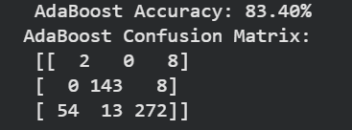
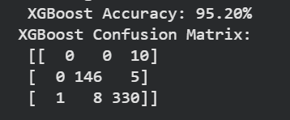

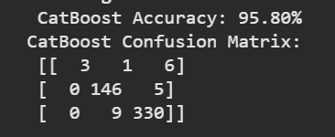

5. Best Model Justification & Deployment
Based on the metrics, CatBoost was selected as the final, winning model. While both XGBoost and CatBoost achieved excellent accuracy (>95%), examining the detailed classification reports reveals why CatBoost is vastly superior for this specific problem.
Due to the severe class imbalance, the XGBoost model overfitted to the majority classes. It achieved 0.00 Precision and 0.00 Recall for the critical "High Risk" (Class 0) category, effectively ignoring it. CatBoost, on the other hand, successfully identified instances of the rare High Risk class (achieving a 1.00 Precision score for Class 0) while maintaining the highest overall weighted F1-score (0.95).
Deployment: The CatBoost model and the TF-IDF vectorizer were serialized using joblib. I then wrapped them in a local FastAPI application (app.py). The API features a /predict endpoint that takes in raw, live text, passes it through the exact same cleaning/vectorizing pipeline used in training, and returns a real-time risk prediction.

